Non-fivtionHello!
Reception Newsletter
Hello 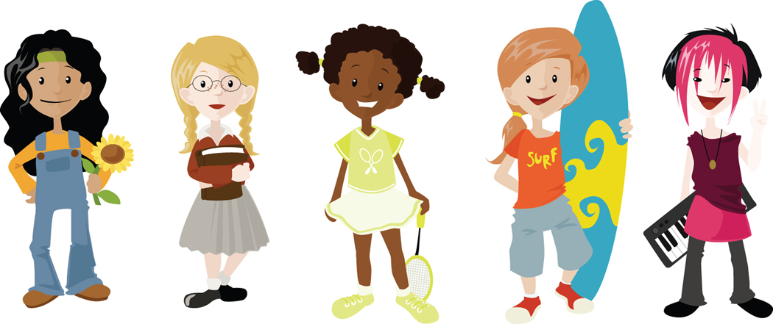
We have had another great week in Reception! We have started talking about seasons and the season of autumn. We have been on an autumn walk and collected lots of different coloured leaves to make a large autumn collage. We have talked about what happens to our world during autumn and watched news time and read non-fiction books about autumn. We have learnt a poem and songs about autumn also. In Maths we have been counting to 100 using the number square and counting in tens. We have been playing simple addition games and even started to record some ‘sums’. In Religion we have been thinking about God’s family and how everyone in the whole world is part of it. In Literacy we have been reading lots of stories about autumn. We have talked about the ‘Little Red Hen’ and how it feels to do all the work with no help! We have talked about harvest time and how lucky we are to have such wonderful food to eat. We were very excited when PC Jo came to tell us all about being a police officer, we looked at her special uniform and even got to try some on !

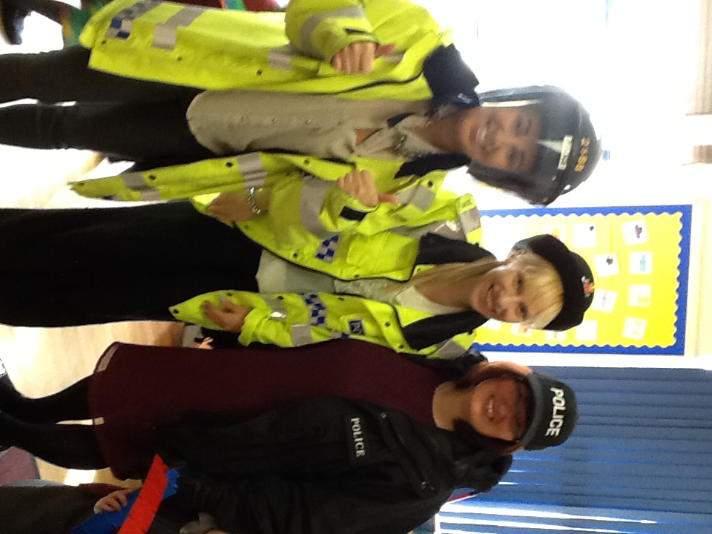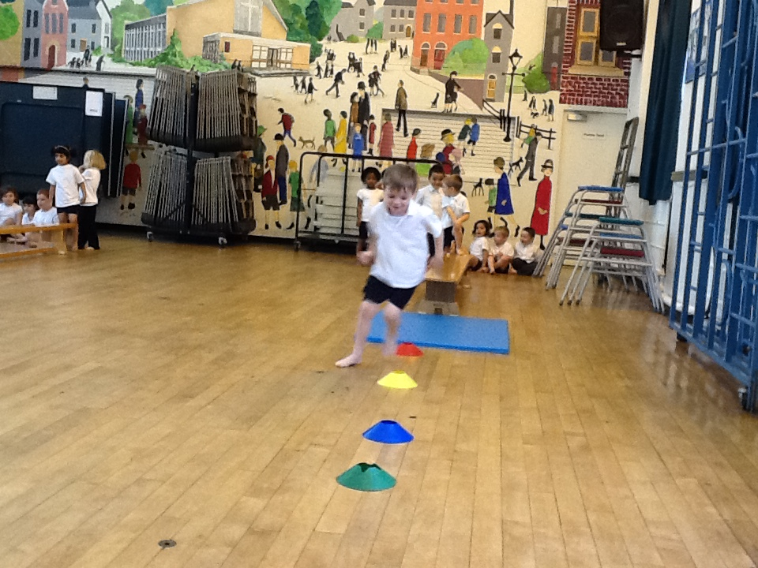

Home Learning: Keep a look out for autumn changes.
Letters and sounds : We have learnt the letter sounds ‘e’ ‘u’’ ‘r’ Please help your child by practising in their sound books and blending to read the flashcards.

Stars of the week
Reception 1 –Adam Biju for great number work . ☺
Reception 2 Olivia George for listening very well to PC Jo and asking great questions – ☺

NOTICE BOARD
Any letters sent home will be placed in the outside notice board. If you for any reason you miss a letter, please see you child’s teacher.
- In the Morning please encourage the children to line up on the main playground in their class lines. Can we ask all parents to stand out of the line to the side so that we can walk our children safely into class. Once we are in the classroom we begin our morning learning, so if you are late please take your child to the main reception office to be signed into school.
- Please ensure all children have their sound books in school by Friday to enable us to keep up to date with their progress and give new sounds.
- Please discourage children bringing in toys from home as they can get upset if they are misplaced.
- We break up for half term next Friday.
- We will be holding a reading and outdoor play meeting for parents on 21st November at 9.00 a.m in the infant hall. We hope to see you all there.
- We are looking for parent helpers after half term to take part in outdoor play activities with the children during the morning. If anyone is interested pleases see your child’s teacher.
- If you haven’t got an appointment for next Thursday for parents evening pleases see your child’s teacher as soon as possible.
- Thank you for your continued support, Miss Moran, Mrs Breen, Miss Carr and Mrs Heitzman ☺

