Our week in Reception!
This week we have been learning all about which foods are good for our bodies. We talked about fruit and vegetables that help us to grow big and strong! In Literacy we read a book called ‘Oliver’s Vegetables’, it is about a little boy who thinks he only likes chips but in the end realises he likes lots of other vegetables too! This is the perfect story to go alongside making vegetable soup because it usually persuades the children to try the soup and many children then realise they do in fact like many more vegetables than they thought they did! In Maths we have been doing lots of number activities up to number 20, the children are really progressing with their knowledge of numbers. In Phonics we have continued with Phase 2 learning 4 new sounds i,n,m and d. We hope to record a video of a phonics lesson to share with you once we have done a few more weeks, this will hopefully help you see how we teach phonics and how you can help your child once they bring home a reading book. On Wednesday we had music with Mrs Ali, we sang songs with actions and played some music with claves and on Thursday we had P.E. This week we also decorated the classroom for Halloween and made pumpkin and skeleton pictures. Please remember we put lots of photos on EExAT if you would like to see your child’s learning and share any home learning also. We hope you all have a lovely half term break.

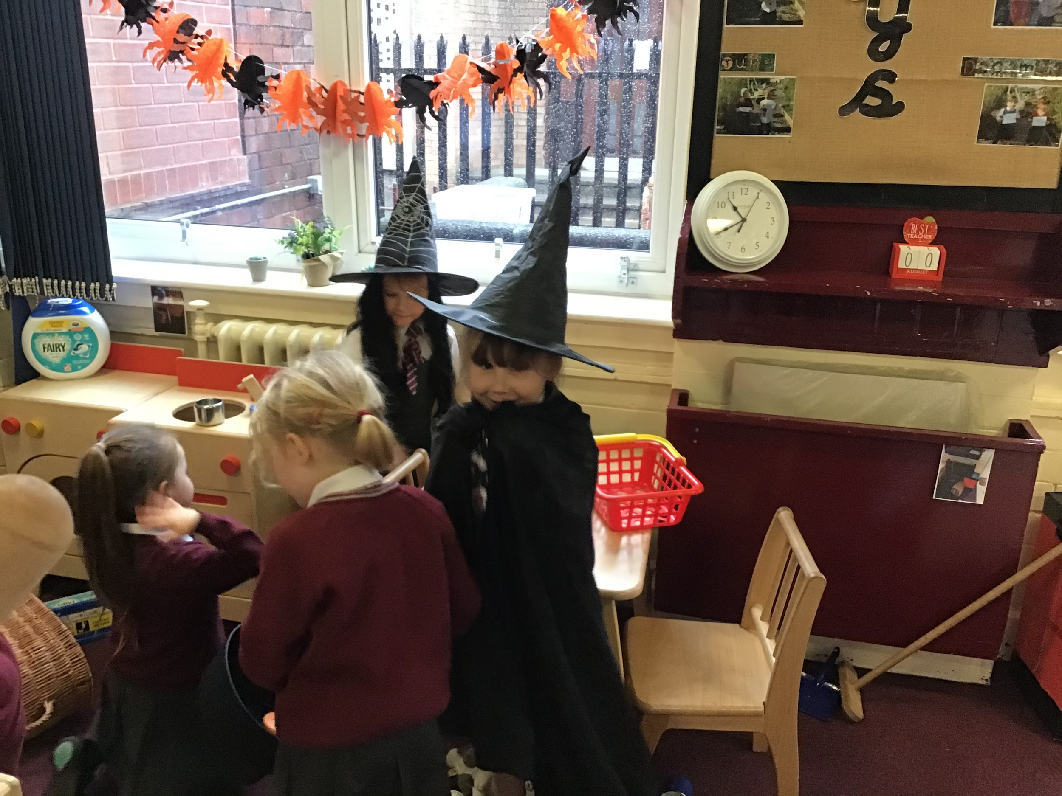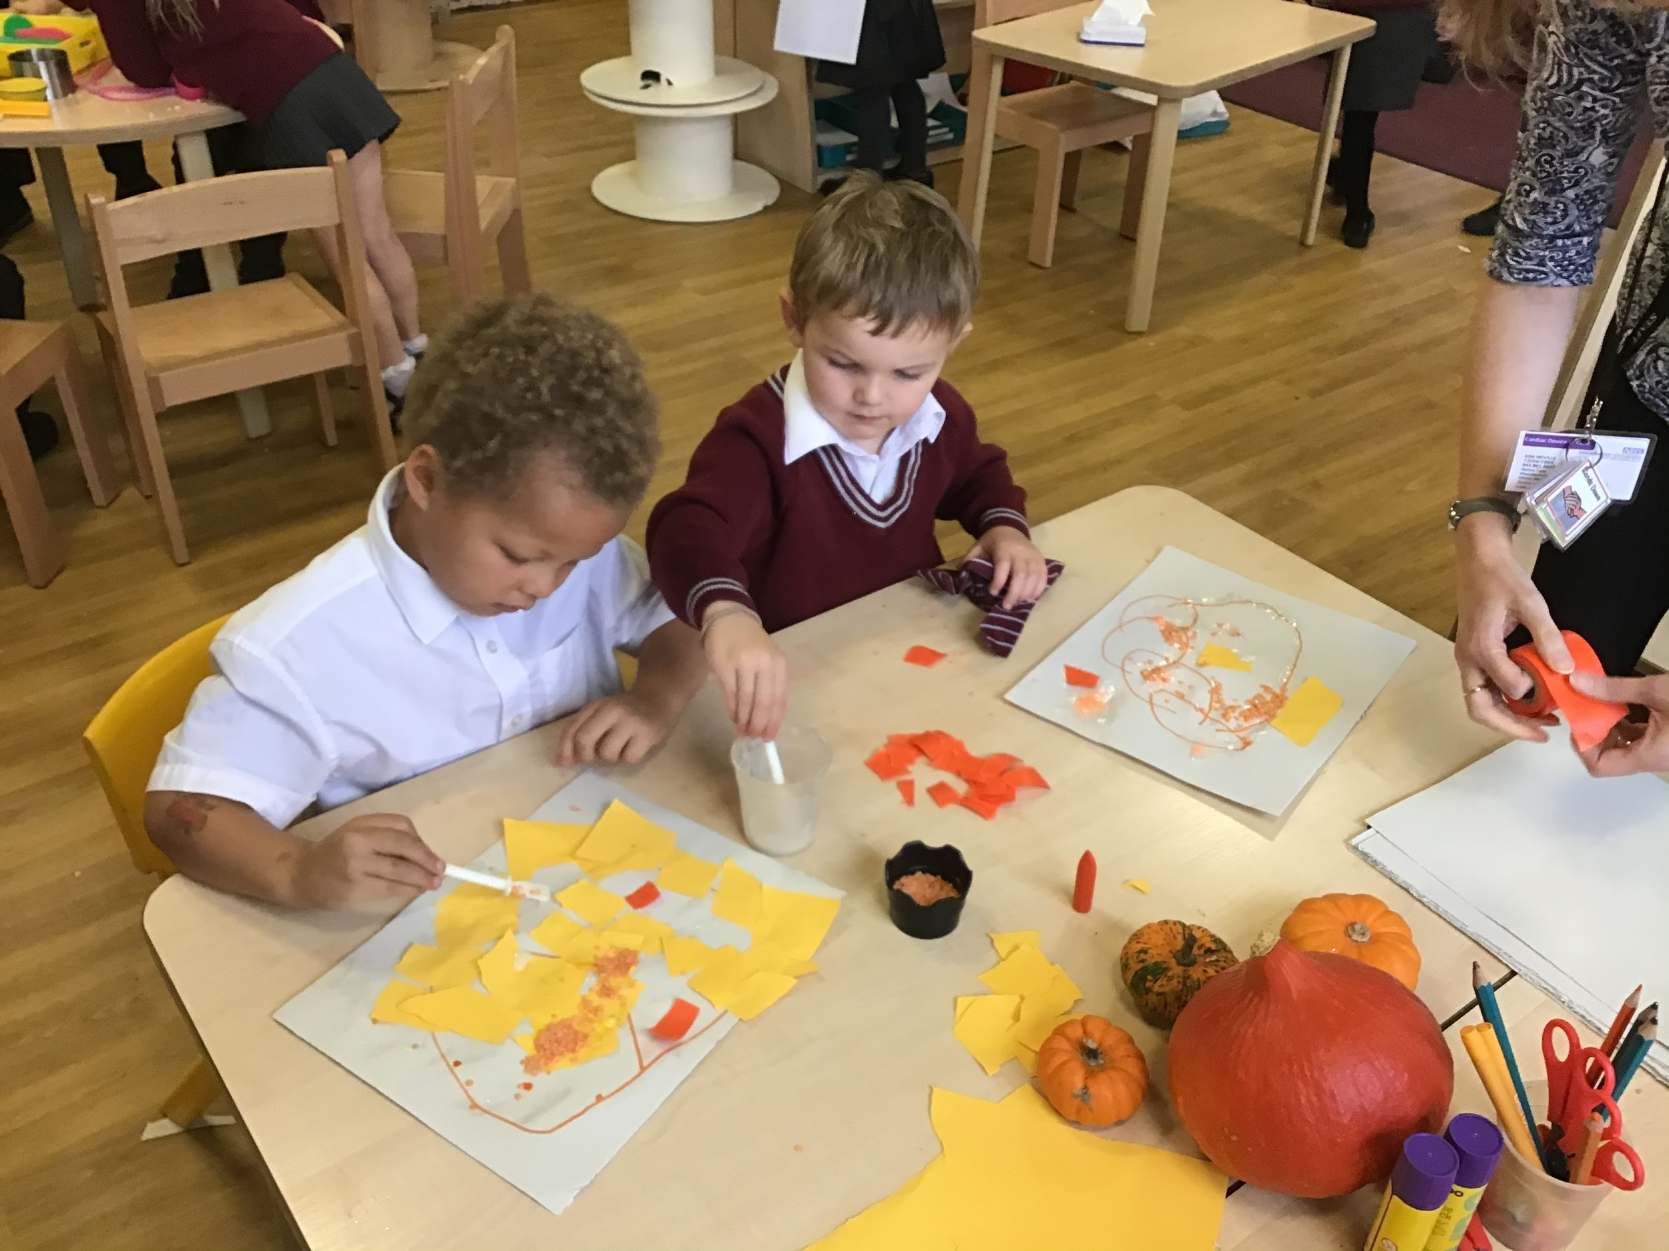
Home Learning :
Please support your child at home to complete the worksheets that accompany this week’s Phonics sounds.

Stars of the week :

Rec 1- Elijah for trying so hard with his fine motor skills work.
Rec 2- Oliver for making a super effort in music.

Everywhere Bear- Isla
Barnaby Bear - Qaison

Notices

*Children are asked to bring in a named water bottle and if they wish a piece of fruit or a vegetable for snack.
*Children need trainers or pumps for PE on a Thursday.
*Please label all items of clothing/shoes/trainers etc
*We are encouraging the children to become more independent, please help your child to put on their own coat and shoes.
* If you haven’t already done so, please log on to your child’s Google classroom account (To access Google classroom the email is your child’s surname and first initial @st-hughlincoln.trafford.sch.uk. The password is sthugh1234.
*We also ask for a voluntary contribution of £1 per week to buy additional resources for our creative activities, special celebrations and baking. This can be sent in weekly on a Monday or every half term. Next half term is 7 weeks so will be £7 if you can but please do not worry if not.
Many thanks for your support,
Mrs Doherty, Mrs Breen and Mrs Neville.

