Our week in Reception!
This week we have started our new topic Autumn. In Literacy we have read a fiction book called ‘Owl Babies’ and we have also looked at a non fiction book all about owls. The children enjoyed watching ‘Owl Babies’ on YouTube and this is something you may wish to also do at home. We have all had a Guided Writing session where we wrote rhyming words on Autumn Leaves.
In Maths we have been doing simple addition and subtraction. We have been looking at number bonds to 5 and the children have especially enjoyed a Maths game on the whiteboard where there are 5 monsters and you put some in the cellar and then write the number sentences to go along with this. In Religion we have started our new topic ‘Welcome’ and talked about how it feels to be welcomed. In Phonics we have continued with Phase 2 learning 4 new sounds ck, e, u and r.We have continued reading and writing cvc words and captions in preparation for reading books. Reading books will be sent home from Monday and returned every Thursday. Please watch the Phonics videos on Google classroom if you need any help with how we teach children to read. Please remember we put lots of photos on EExAT if you would like to see your child’s learning and share any home learning also. Next week we are going to be talking about Diwali, if you celebrate Diwali in your family we would love to see some photos if possible and we hope you enjoy the celebrations this weekend.

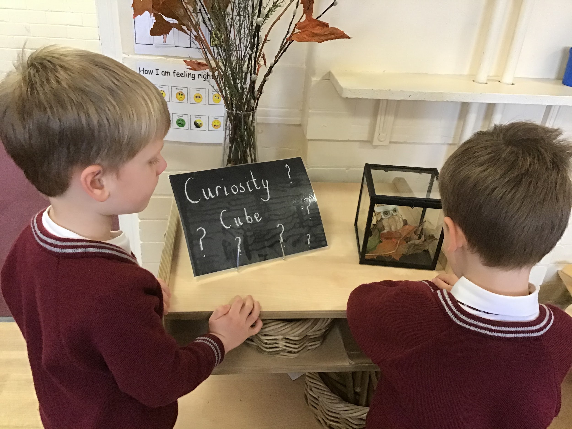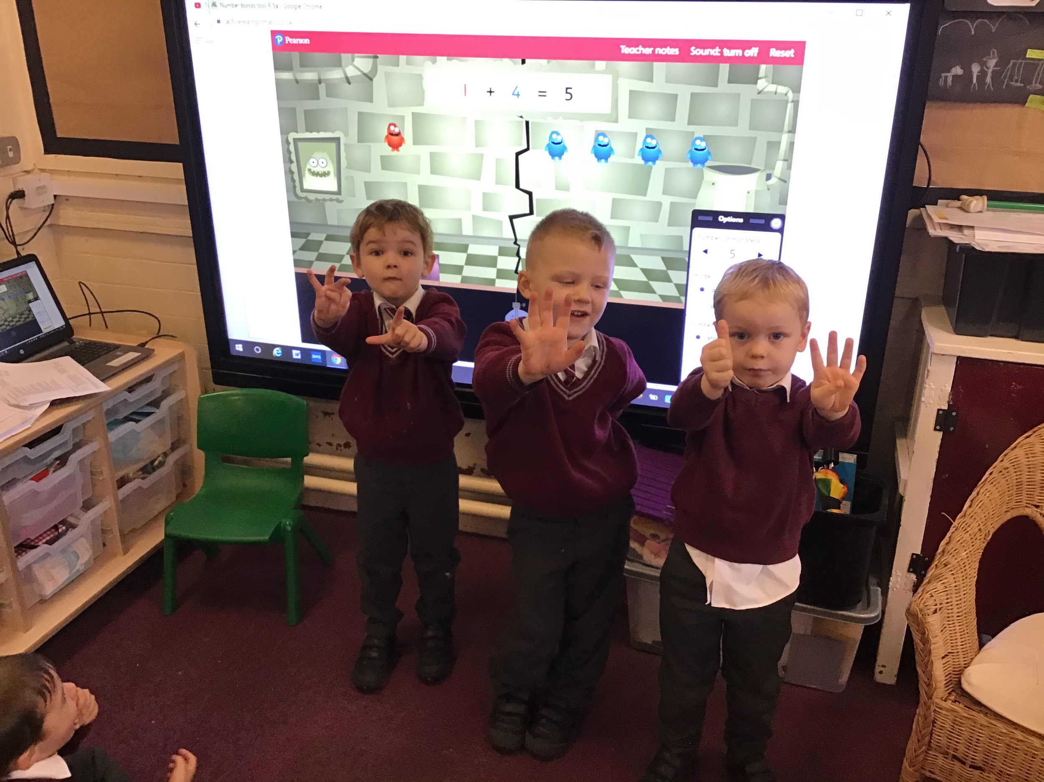
Home Learning :
Please support your child at home to complete the worksheets that accompany this week’s Phonics sounds.

Stars of the week :

Rec 1- Fletcher for trying so hard in Phonics.
Rec 2- Jacob for trying so hard in Phonics.

Everywhere Bear- Hassan
Barnaby Bear - Alfie-J

Notices

*Children are asked to bring in a named water bottle and if they wish a piece of fruit or a vegetable for snack.
*Children need trainers or pumps for PE on a Thursday.
*Please label all items of clothing/shoes/trainers etc
*We are encouraging the children to become more independent, please help your child to put on their own coat and shoes.
* If you haven’t already done so, please log on to your child’s Google classroom account (To access Google classroom the email is your child’s surname and first initial @st-hughlincoln.trafford.sch.uk. The password is sthugh1234.
*We also ask for a voluntary contribution of £1 per week to buy additional resources for our creative activities, special celebrations and baking. This can be sent in weekly on a Monday or every half term.
Many thanks for your support,
Mrs Doherty, Mrs Breen and Mrs Neville.

